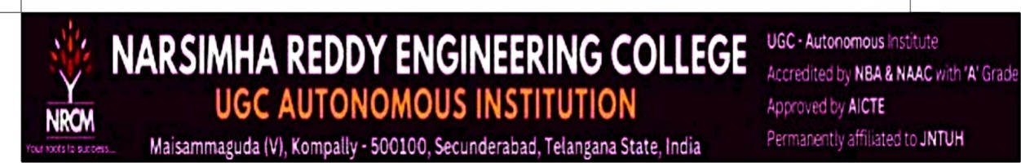

Project Based Learning
On
CIRCULAR STAIRCASE DESIGN USING AUTOCAD
By
GOGULA SHIVA PRASAD (26X05A0106)
UNDER THE GUIDANCE OF
MR.SHAIK KHALEEL
AUTOCAD TRAINER
DEPARTMENT OF CIVIL ENGINEERING

NARSIMHA REDDY ENGINEERING COLLEGE (UGC-AUTONOMOUS) APPROVED BY AICTE, AFFILIATED TO JNTUH, ACCREDITED BY NBA & NAAC WITH A-GRADE)
MAISAMMAGUDA (V), KOMPALLY, SECUNDERABAD,
500100.(2026-2027)

